**Hurricane Matthew Media Coverage Oct. 9 - 11 (11:30am)**

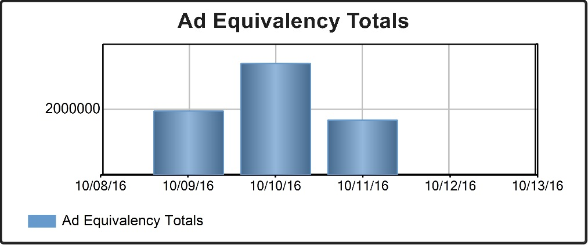

**Oct 9 – $1,945,221.78**

**Oct 10 – $3,398,206.43**

**Oct 11 - $1,669,939.65 so far**

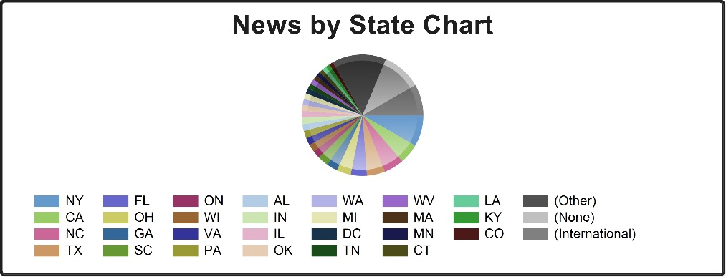

**Top 3 States: New York, California, North Carolina**

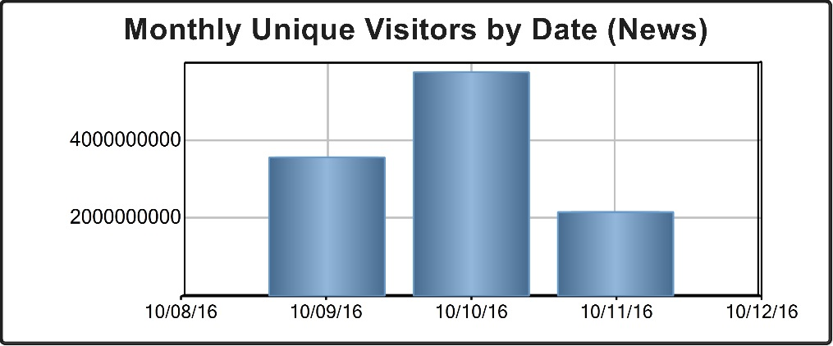

**Oct. 9 – 3,554,511,224**

**Oct. 10 – 5,737,658,336**

**Oct. 11 – 2,147,954,114**