**TV Eyes Analysis of Gov. Mentions**

**Oct. 7 – 11 (2:45pm)**

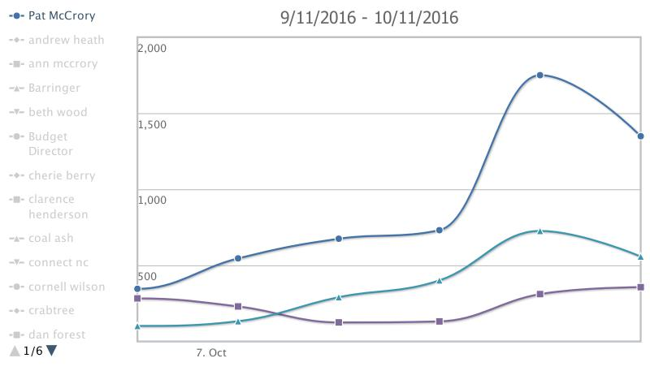

**Oct 7 - 909**

**Oct 8 – 1,091**

**Oct 9 – 1,264**

**Oct 10 – 2,787**

**Oct 11 – 2,264**