**Hurricane Matthew Media Coverage Oct. 14**

**989 News Results**

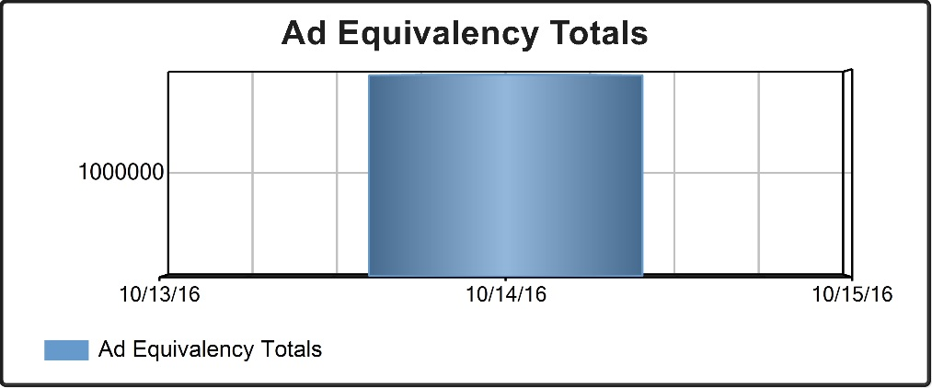

**Oct. 14 - $1,949,717.81**

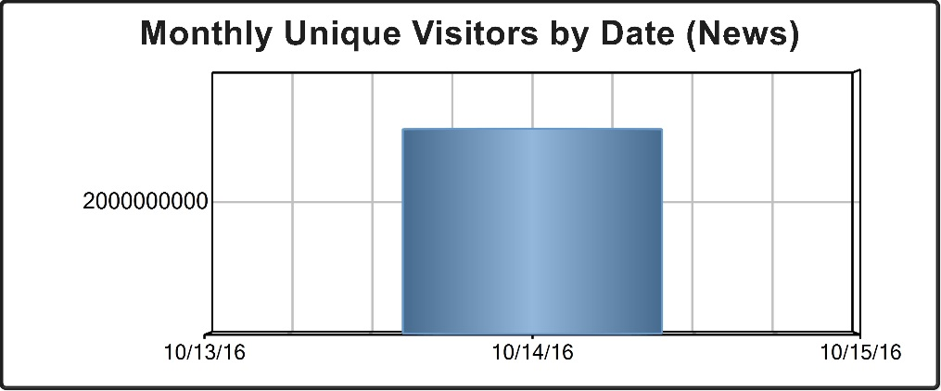

**Oct. 14 – 3,112,519,640**

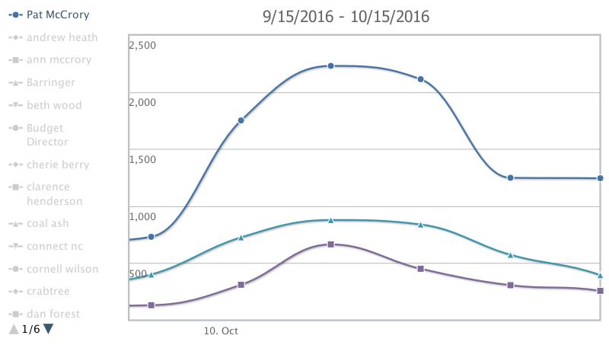

**TV Eyes Mentions: 2,128**